**A Project Documentation**

**on**

**“Adding File Associations via MSI”**

**By**

**Kamran Akmal (34958)  
Gaddapara Chenchu Umasree (34935)**

**Tejas Madan Zinjade (34957)**

**Shrawani Balwadkar (34932)**

**INTERNAL GUIDE**

**Trainer: Harinya Mam**

**Submitted To**





**ADDING FILE ASSOCIATIONS VIA MSI**

* **Objectives:**

The primary objective of this project is to configure MSI packaging in such a way that the **Application** is automatically set as the **default application for some extensions (**Like: .pdf, .bat**) files** during installation.

This ensures:

* **Standardization** – All users have the same default application for opening some extensions across the enterprise.
* **User Experience** – Eliminates user confusion with multiple application as they get a default application.
* **Support Reduction** – Minimizes helpdesk tickets related to incorrect file associations.
* **Automation** – No manual intervention needed post-installation.
* **Compliance** – Ensures organizational control over software defaults.

By embedding file associations directly into the MSI (via **Advanced Installer’s File Association Wizard** or **Registry Table modifications**), organizations gain a consistent and policy-driven way to enforce default application behavior.





* **Project Requirements:**

**Hardware Requirements**

| **Component** | **Minimum Specs** | **Notes** |
| --- | --- | --- |
| CPU | x64, 2+ cores | Required for MSI repackaging tools |
| RAM | 4 GB (8 GB recommended) | Advanced Installer can consume memory while building projects |
| Storage | 10 GB free space | For storing original/modified MSIs and testing logs |
| OS | Windows 10/11, Server 2016+ | Essential for MSI execution and registry verification |

**Software Requirements**

| **Tool** | **Purpose** | **Download** |
| --- | --- | --- |
| **Advanced Installer** | GUI-based MSI modification, File Association Wizard | advancedinstaller.com |
| **Orca (Windows SDK)** | Inspect and edit MSI tables (Extension, ProgId, Verb) | Microsoft SDK |
| **InstEd** | Lightweight MSI editor | instedit.com |
| **PowerShell 5.1+** | Registry verification, automation | Built into Windows |
| **Process Monitor** | Track registry/file changes | Sysinternals |

**Deployment Tools**

| **Tool** | **Use Case** |
| --- | --- |
| **MSIEXEC (Built-in)** | Install MSI with parameters or transforms |
| **SCCM / Intune** | Enterprise deployment of MSI packages |
| **Group Policy** | Enforce file type association XMLs or registry settings |

* **Execution Overview:**

There are three primary approaches to configure file associations for extension files in applications:

* **Using Advanced Installer File Association Wizard**

**Step1: Open Project**

* Launch **Advanced Installer**.
* create a **New MSI project**
* Add the application in Files and Folders

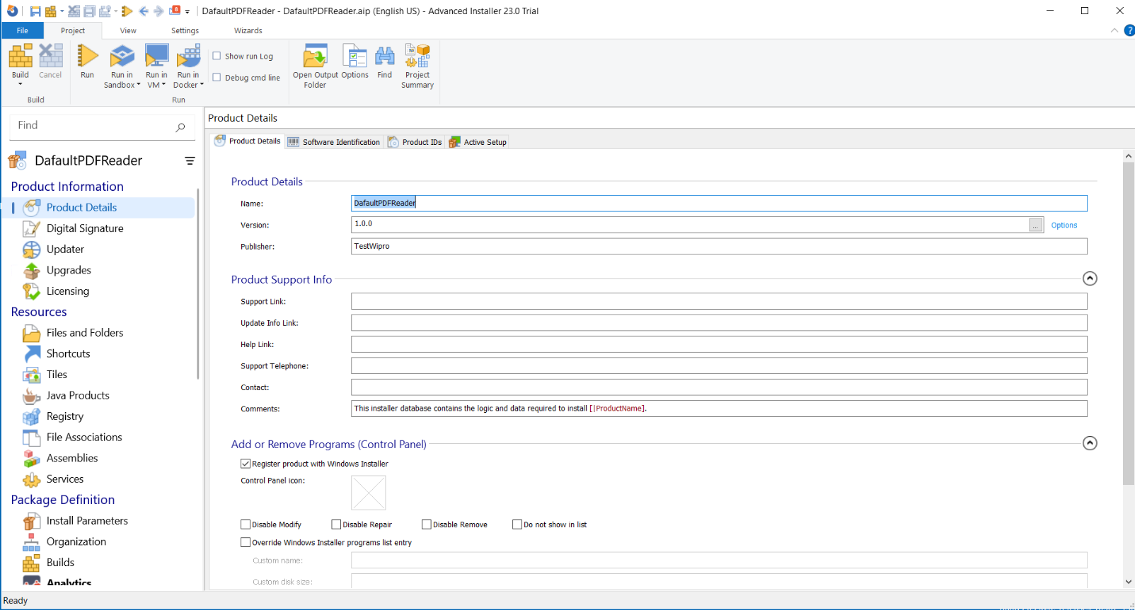

**Files and Folders**

* Adding Foxit PDF Reader in the Application Folder

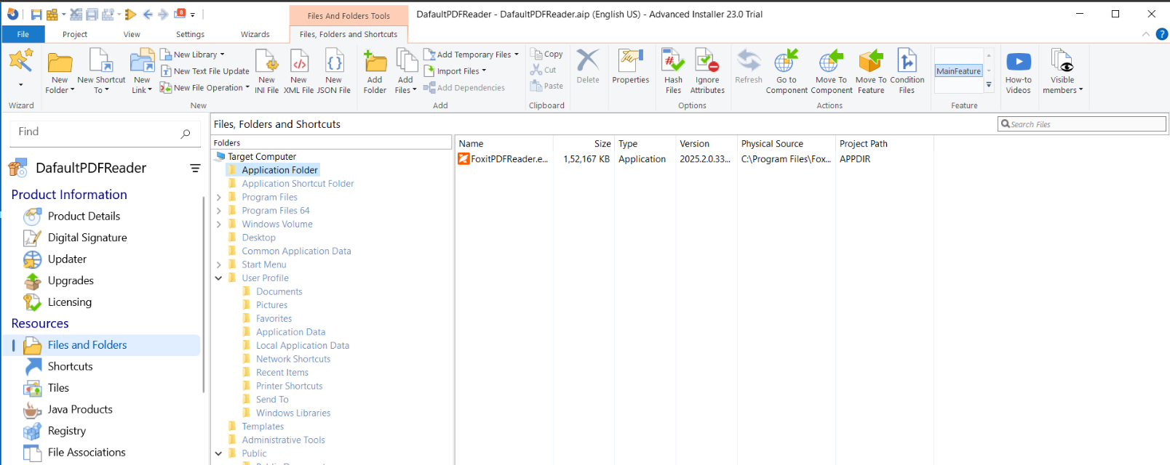

**Adding Apllication Option**

**FoxintPDFReader.exe Added**

**Step2: Add a New Association**

* In the **left panel**, expand **Resources** → click **File Associations**.
* Click **New Extension**.
* Set the extension to **.pdf**.
* **Command** → APPDIR/FoxitPDFReader.exe
* **MIME Type** → application/pdf.

**Command** → APPDIR/FoxitPDFReader.exe

**MIME Type** → application/pdf.

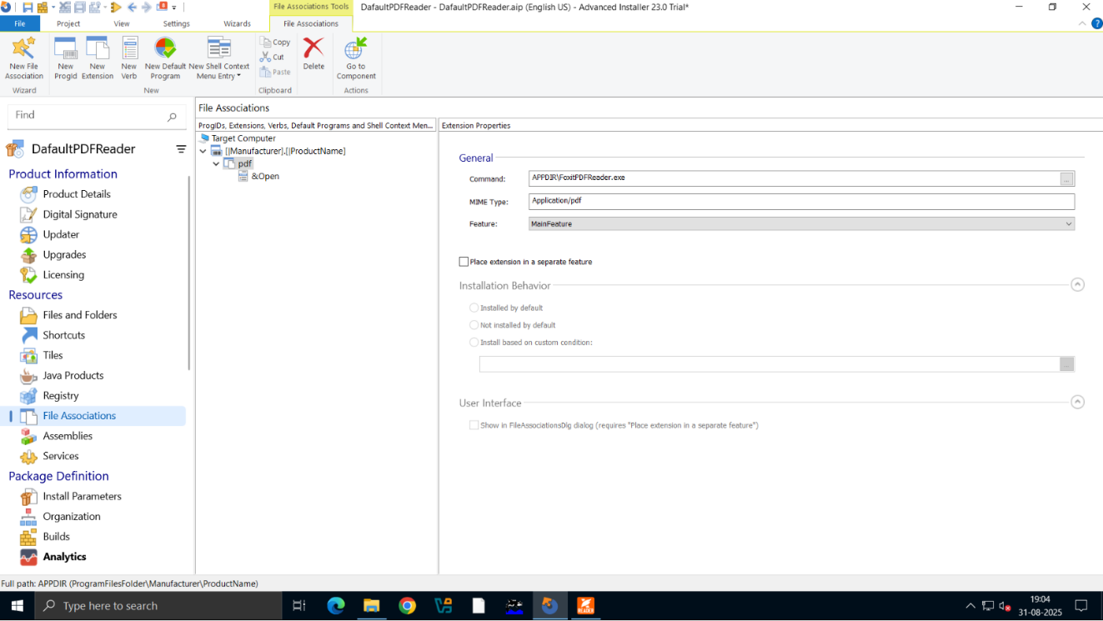

**Create New Extension**

**Naming it As pdf (For Opening .pdf files)**

**File Association Option**

**Step3: Define Properties**

* **Verb** → “Choosing how it behave”
* **Icon** → “Selecting from the exe file”

**Choosing the Verb as Open**

**Choosing the Icon**

**Step4: Build the Project**

* Click **Build** in the ribbon.
* This will generate a new MSI with the file association included.

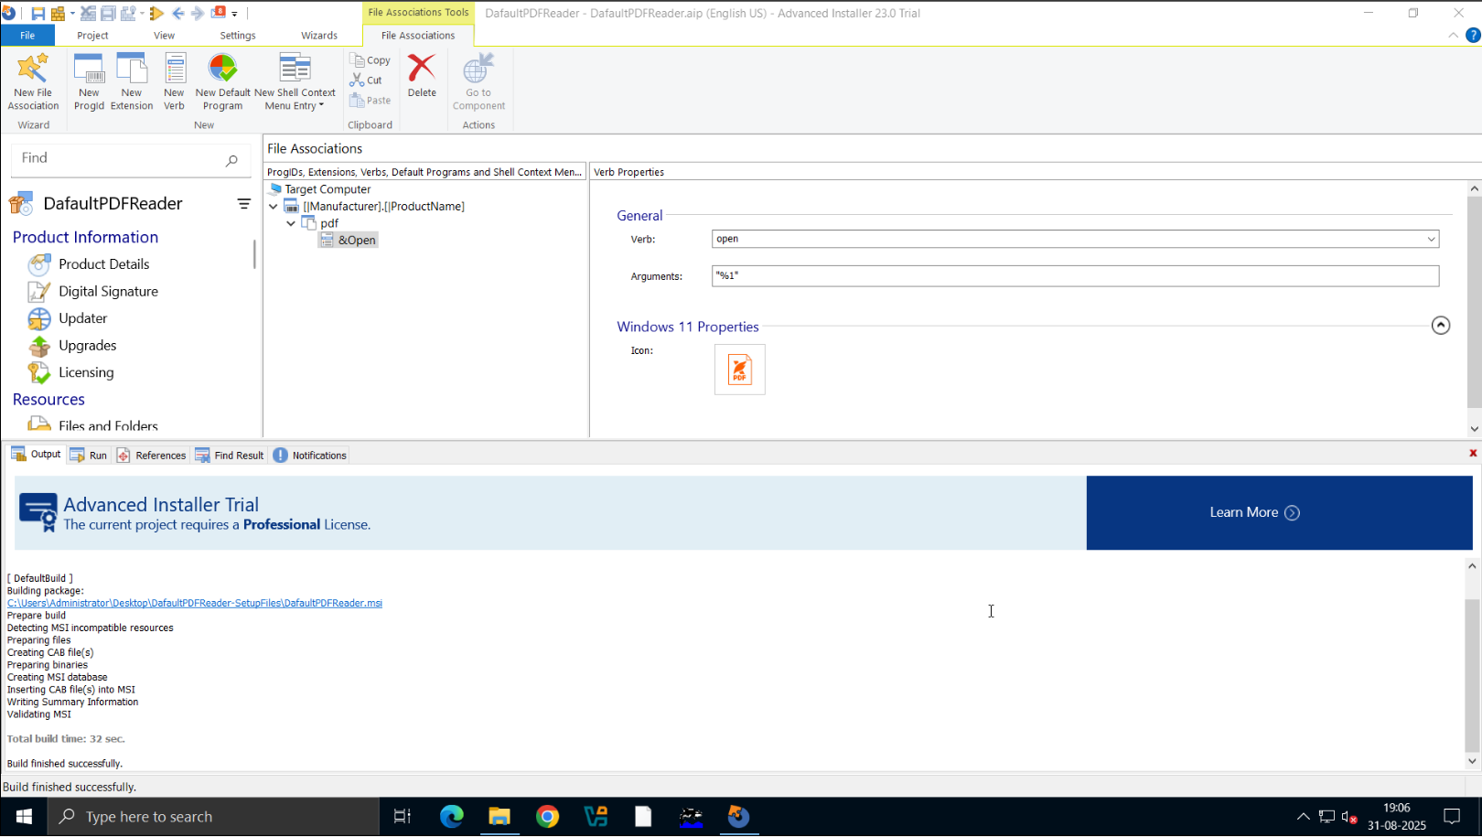

**Build Finished Successfully**

**Building the application with Associated Extension**

**Step5: Test the MSI**

* Install on a clean VM.

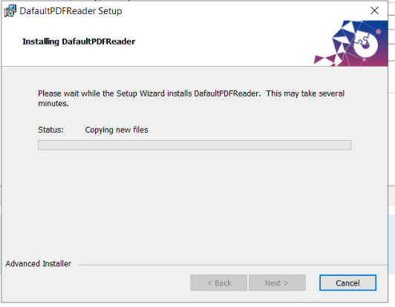

* Double-click any .pdf file → it should open with **Foxit Reader**.

* **Tools and Technology Used**
* **Microsoft Windows 10/11** – Test environments.
* **Advanced Installer** – Primary MSI modification tool.
* **Foxit Reader MSI** – Target application.
* **Snipping Tool** – Documentation and evidence capture.
* **References**
* [Advanced Installer – File Associations](https://www.advancedinstaller.com/user-guide/file-associations.html)

* [Windows Installer Portal](https://learn.microsoft.com/en-us/windows/win32/msi/windows-installer-portal?utm_source=chatgpt.com)
* [MSIExec Documentation](https://learn.microsoft.com/en-us/windows-server/administration/windows-commands/msiexec?utm_source=chatgpt.com)
* [Microsoft Community](https://learn.microsoft.com/en-us/windows/win32/shell/fa-intro)
* [Wikipedia File association](https://en.wikipedia.org/wiki/File_association)